**ANC Hemoglobin Descriptive Statistics**

Scatter Plot for Hemoglobin vs. Gestational Age by measurement method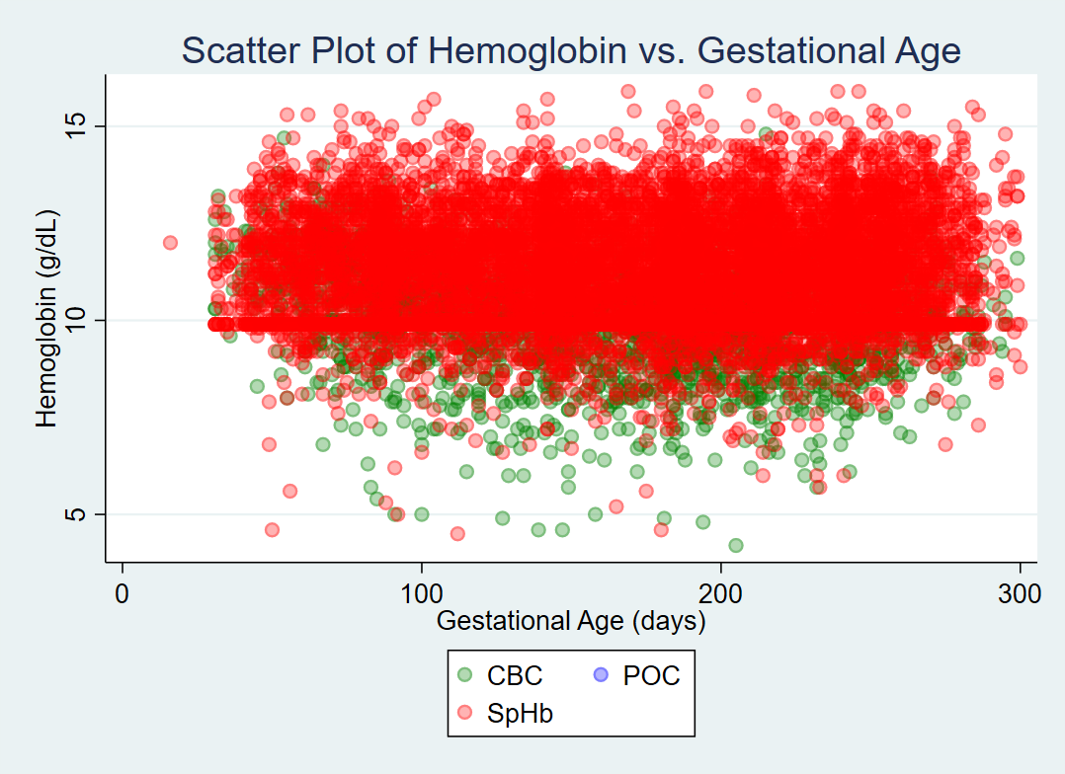

Histogram of Hemoglobin Levels (all methods)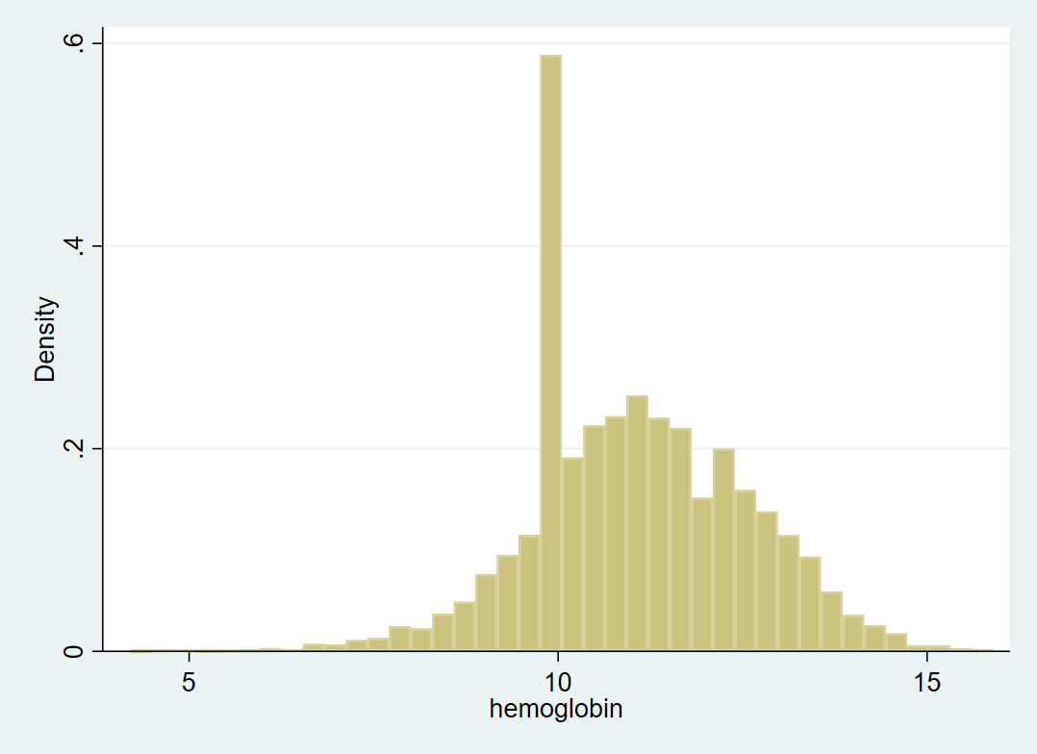

Histogram of Hemoglobin Levels by trimester (all methods)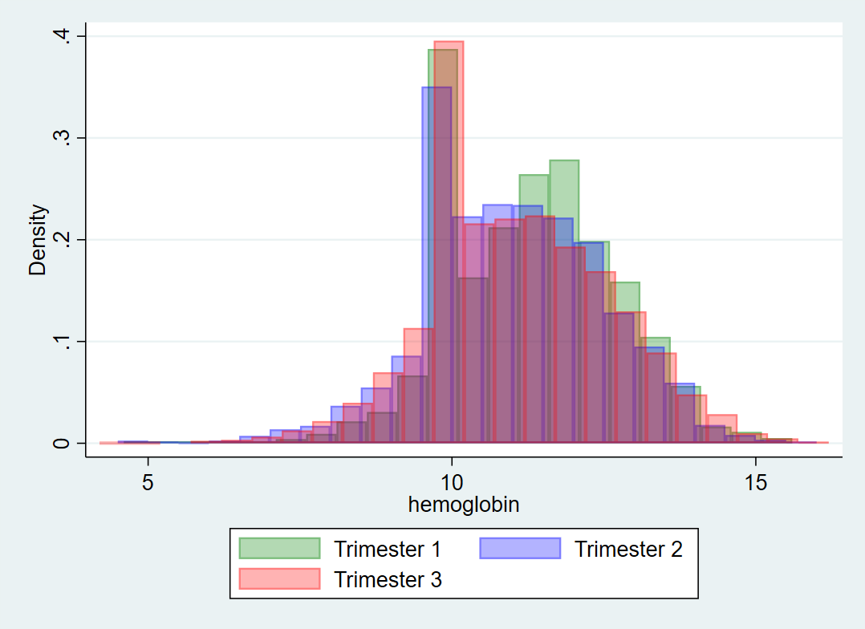Histogram of Hemoglobin Levels by trimester (all methods)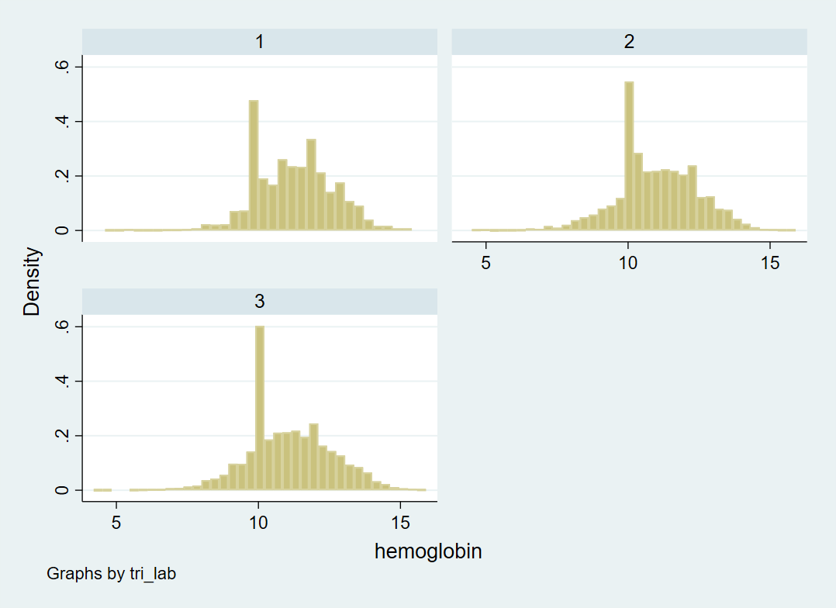

Histogram of Hemoglobin Levels (CBC only)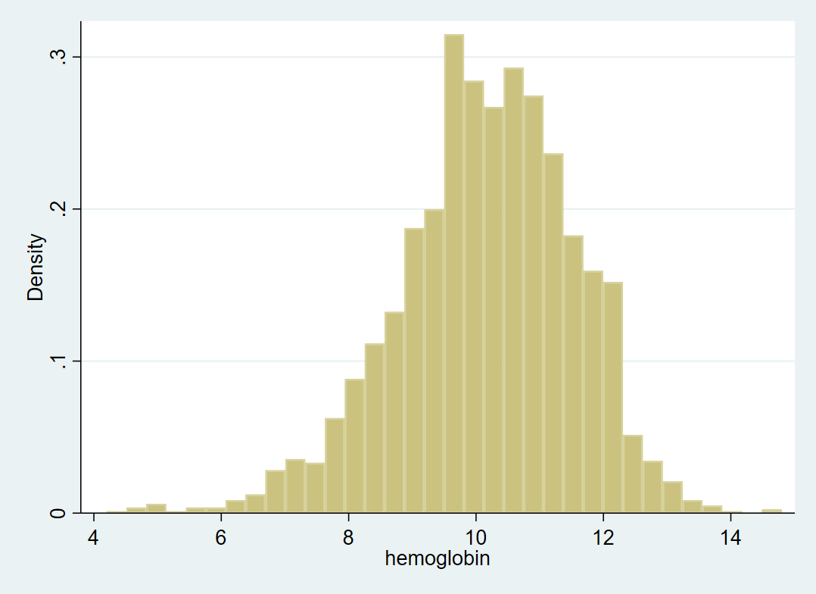

Histogram of Hemoglobin Levels by trimester (CBC only)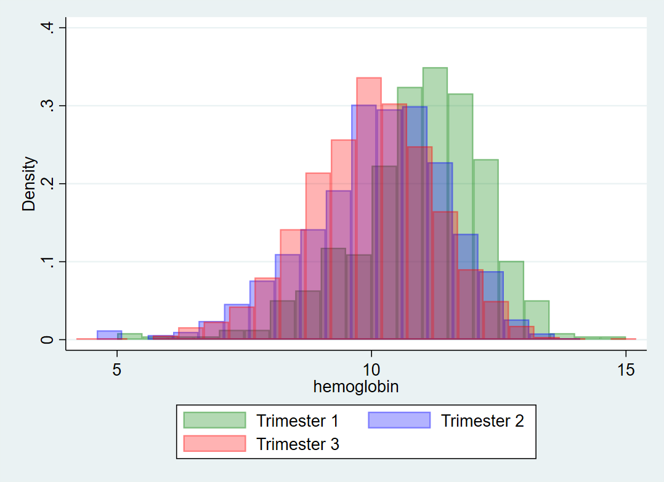Histogram of Hemoglobin Levels by trimester (CBC only)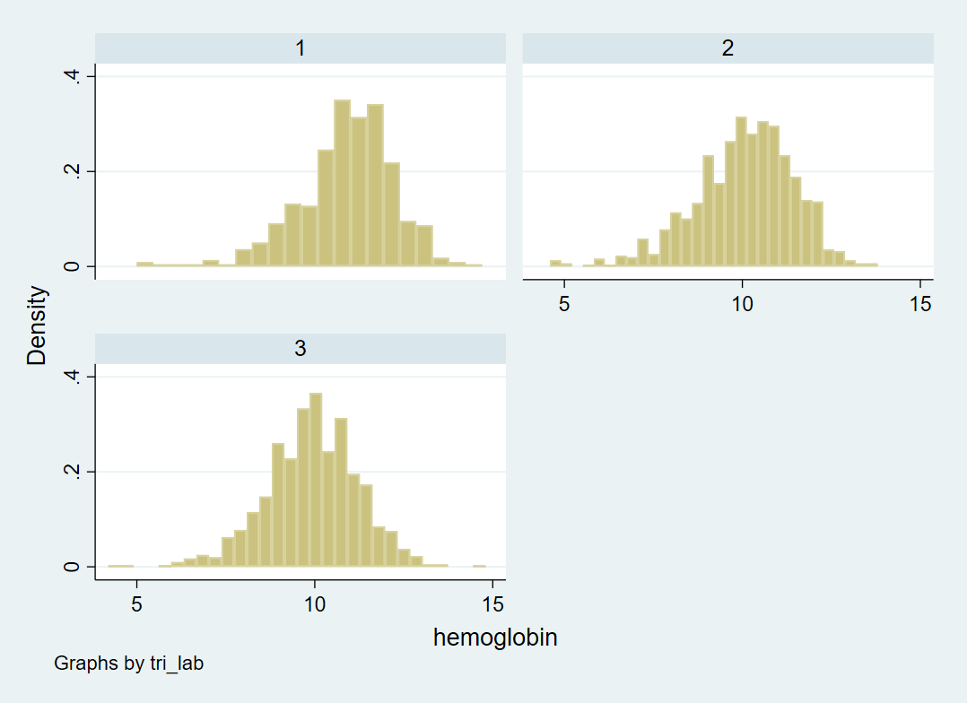

Histogram of Hemoglobin Levels (SpHb only)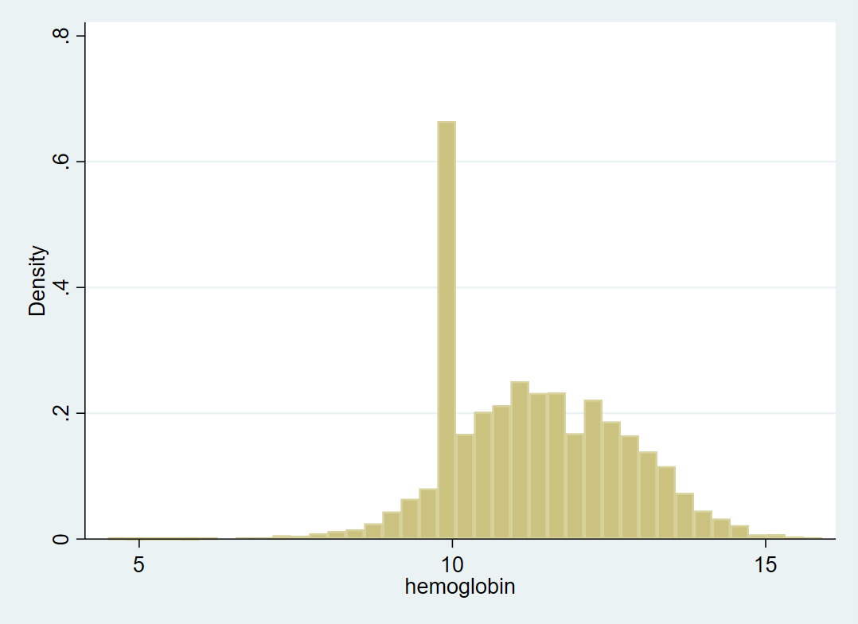

Histogram of Hemoglobin Levels by trimester (SbHb only)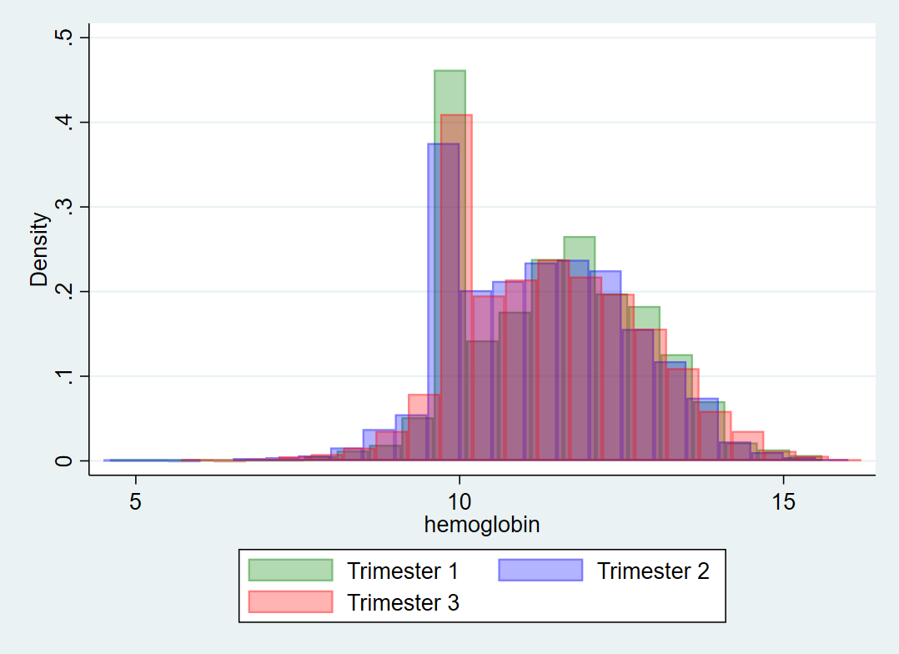Histogram of Hemoglobin Levels by trimester (SbHb only)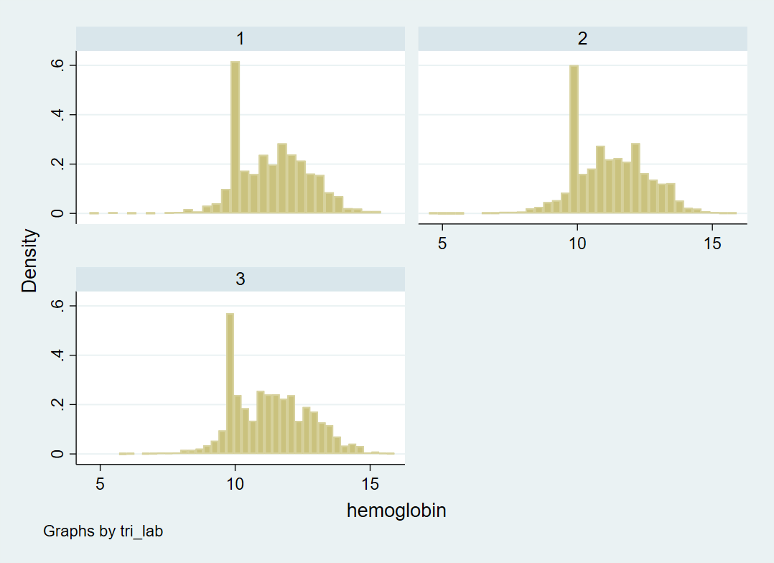

Comparison of Same-day Hemoglobin Measures